z

A

Mini Project Report

on

**ONLINE ASSESSMENT MODULE**

Submitted to



**BHILAI INSTITUTE OF TECHNOLOGY, DURG**

An Autonomous Institute

Affiliated to

**Chhattisgarh Swami Vivekanand Technical University, Bhilai (C.G.)**

***In partial fulfillment of the requirements for the award of***

**Bachelor of Technology**

in

**Computer Science and Engineering, Semester**

Gajendra Sahu University Roll No.: 300102221021

Gourav Yadav University Roll No.: 300102221102

Kavya Swarnkar University Roll No.: 300102221050

**Under the Guidance of**

**PROF. MONIKA VERMA**

**Session 2022-2023**

**DECLARATION BY THE CANDIDATES**

We the undersigned solemnly declare that the report of the project work entitled Online Assessment Module, is based on my own work carried out during the course of our study under the supervision of Dr. (Mrs.)Sunita Soni.

We assert that the statements made and conclusions drawn are an outcome of the project work. We further declare that to the best of our knowledge and belief that the report does not contain any part of any work which has been submitted for the award of any other degree/diploma/certificate in this University/ any other University of India or any other country.

|  |  |  |
| --- | --- | --- |
| (Signature of the Candidate)  Name: Gajendra Sahu  URNo.: 300102221021  Enrollment No.:CA6458  Sem: 3rd | (Signature of the Candidate)  Name: Gourav Yadav  URN: 300102221102  Enrollment No.: CB295  Sem:3rd | (Signature of the Candidate)  Name: Kavya Swarnkar  URN: 300102221050  Enrollment No.: CA6446  Sem:3rd |

**CERTIFICATE**

This is to certify that the report of the project submitted is an outcome of the project work entitled Online Assessment Module is carried out under my guidance and supervision for the award of Degree in Bachelor of Engineering in Computer Science from Chhattisgarh Swami Vivekanand Technical University, Bhilai (C.G).

To the best of my knowledge the report

i) Embodies the work of the candidate himself / herself,

ii) Has duly been completed,

iii) Fulfills the requirement of the Ordinance relating to the BE degree of the University,

iv) Is up to the desired standard for the purpose of which is submitted.

Signature of Coordinator

Prof Monika Verma

Computer Sc. & Engg.

The Project work as mentioned above is hereby being recommended and forwarded for examination and evaluation.

Dr. (Mrs.) Sunita Soni

Head of the Department

Computer Sc. & Engg

**CERTIFICATE BY THE EXAMINERS**

This is to Certify that the project the entitled

“ONLINE ASSESSMENT MODULE”,

Submitted by

|  |  |  |
| --- | --- | --- |
| Name: Gajendra Sahu | Enrollment No.: CA6458 | Roll No.: 300102221021 |
| Name: Gourav Yadav | Enrollment No.: CB4295 | Roll No.: 300102221102 |
| Name: Kavya Swarnkar | Enrollment No.: CA6446 | Roll No.: 300102221050 |

Have been examined by the undersigned as a part of the examination for the award of Bachelor of Engineering degree in Computer Science and Engineering from Chhattisgarh Swami Vivekanand Technical University, Bhilai (C.G)

|  |  |
| --- | --- |
|  |  |
| Internal examiner | External examiner |
| Date: | Date: |

**ACKNOWLEDGEMENT**

We have great pleasure in the submission of this project report entitled ONLINE ASSESSMENT MODULE in partial fulfillment the degree of Bachelor of Engineering (CSE). While submitting this Project report, we take this opportunity to thank those directly or indirectly related to project work.

We would like to express sincere thanks and gratitude to Dr. Mohan Kumar Gupta, Principal of the Institution, Dr. (Mrs.) Sunita Soni, Head of the Department Computer Science & Engineering for their encouragement and cordial support.

While Submission of the project, we would also like to thank Prof. Mrs. Monika Verma, Project Coordinator, faculty and all the staff of department of Computer Science & Engineering, Bhilai Institute of Technology, Durg for their continuous help and guidance throughout the course of project.

Also, we would extend our gratitude to our parents, family members, friends and all others who have helped us directly or indirectly in the successful completion of the project work.

|  |  |  |
| --- | --- | --- |
| Name: Gajendra Sahu | Enrollment No.: CA6458 | Roll No.: 300102221021 |
| Name: Gourav Yadav | Enrollment No.: CB4295 | Roll No.: 300102221102 |
| Name: Kavya Swarnkar | Enrollment No.: CA6446 | Roll No.: 300102221050 |

**ABSTRACT**

The internet revolution brought a lot of opportunities in the education sector and the pandemic taught us the modern need of technology for e learning purposes. The manual method of conducting quizzes, marking all individuals copy and storing their report consumes a lot of time of the faculties and makes a hectic work load on them.

The report consists of the working and result of the Online Assessment Module also it consists of the future scope and implementation that can be done to improvise the project and increase the level of the project to be used at universities. The main objective of Online Assessment Module is to minimize the work load and the issues regarding the manual method of conducting quizzes.

This Website is made to help and ease out assessment taking in the Computer Science And Engineering Dept. of Bhilai Institute Of Technology, Durg (CG)

**CONTENTS**

|  |  |
| --- | --- |
| **TOPICS** | **PG.NO** |
| 1.INTRODUCTION  1.1 PROJECT DESCRPITION  1.2 METHODOLOGY | 09-11 |
| 2. SOFTWARE REQUIREMENTS | 12 |
| 3. SCHEMA   * 3.1 SCHEMA FOR STUDENT'S REGISTRATION * 3.2 SCHEMA FOR TEACHER'S REGISTRATION * 3.3 SCHEMA FOR QUESTION ADDITION | 13 - 15 |
| 4. RESULT   * + HOME PAGE   + STUDENT'S LOGIN AND REGISTER PAGE BUTTON   + STUDENT'S REGISTRATION AND LOGIN   + STUDENT’S INTERFACE   + TEST FOR STUDENT   + REPORT OF STUDENT   + TEACHER'S LOGIN AND REGISTER PAGE BUTTON   + TEACHER'S REGISTRATION AND LOGIN   + TEACHERS INTERFACE   + ADDITION OF QUESTION BY TEACHER   + STUDENT REPORT | 16 - 22 |
| 5. CONCLUSION | 23 |
| 6. FUTURE SCOPE   * 6.1 SCOPE * 6.2 FUTURE APPLICATION AND IMPLEMENTATION | 24 |
| 7.ADVANATAGES | 25 |
| 8.BILIOGRAPHY | 26 |

**REFRENCRES OF FIG**

|  |  |  |
| --- | --- | --- |
| **FIG NUMBER** | **DISCRIPTION** | **PAGE NUMBER** |
| 3.1.1 | Schema For Student Registration | 13 |
| 3.2.1 | Schema For Teacher Registration | 14 |
| 3.3.1 | Schema For Adding Question | 15 |
| 4.1 | Homepage | 16 |
| 4.2 | Login Or Register Option For Student | 16 |
| 4.3 | Student Registration Page | 17 |
| 4.4 | Student Login Page | 17 |
| 4.5 | Interface For Logged In Student | 18 |
| 4.6 | Test Interface | 18 |
| 4.7 | View Report Student | 19 |
| 4.8 | Login Or Register Option For Teacher | 19 |
| 4.9 | Teacher Registration Page | 20 |
| 4.10 | Teacher Login Page | 20 |
| 4.11 | Interface For Logged In Teacher | 21 |
| 4.12 | Create Question | 21 |
| 4.13 | Student Report | 22 |

**1.INTRODUCTION**

Nowadays, a lot of universities in our country and each of the university consist of student up to two thousand. In order to handle a large amount of student may cause a lot of problem especially in management in the quiz manually.

The use of online quiz systems has become quite popular in the recent years due to pressures of increasing class sizes and the need for more efficient and effective methods of assessing distant students. It is due to the popularity of distant education. Still now maximum educational institutes have been using manual system to take quiz.

The aim of this project is to computerized the existing manual system and help the examiners to save their valuable time and important data, checking the answer sheets after taking test, waste the examiners time, so this application will check the correct answer and save the examiner time. Apart from this, data which are exist in this system, will exist for long period of time and will be easily accessible. This project helps the examiners to manage their services in a good way and provide a better service to both faculty and students.

The objective of this project is to manage the details of students, examinations, marks, courses and papers in a good manner. The performance of the application will be fully control by administrator and administrator can guaranty any one to access. The project will reduce the manual process in managing examinations and all issues regarding that.

**1.1PROJECT DESCRPITION**

The ‘Online Assessment Module’ project will be developed to overcome the time-consuming problem of manual system. Functionalities of the project are as follows:

* Examiners will be able to punch the MCQ questions online.
* Able the users to solve the questions online.
* Examiners can manage the information regarding exam.
* Correct answers will be evaluated by system (First it should be determined by examiner).
* Users can see their result after submitting the test.
* All the records of the students will be stored.

**1.2. METHODOLOGY**

The concept behind the Module if simple we have used these modules and these modules have logical connections to other modules as they are interdependent.

**Teacher Login:** Able the teachers to login to system with a valid email id and password. If a teacher is successfully login to system, he/she will have access to following pages:

* **Teacher Home:** Which have information about Online MCQ Quiz and issues support by this system for the teachers.
* **Create Test:** Which able the teacher to punch a test and will be able to add questions to the particular test.
* **Students Marks:** Which able the teacher to observe the result of all student who have attempted the tests.

**Student Login:** Able the students to login to system with a valid email id an and password. If student is successfully login to system, he/she will have access to following pages:

* **Student Home:** Which have information about Online MCQ Quiz and issues support by this system for students.
* **Attempt Test:** Which able the student to select a particular test for attempting from the existing test and questions of selected test will be displayed for the student to attempt. Then student will be able to attempt the questions and submit it.
* **Marks:** Which able the particular students to have access to result of the test which he/she attempted.

**2. SOFTWARE REQUIREMENTS**

**2.3 Development End Software Requirement**

* HTML
* CSS
* JavaScript
* Mondo DB
* NodeJS

**2.2 User End Software Requirement**

* Google Chrome or any other web browser.
* Windows 8 or above.

**2.3 Development End Software Requirement**

* NodeJS
* MongoDB Compass

**3. SCHEMA**

**3.1 SCHEMA FOR STUDENT'S REGISTRATION**

Below image depicts the structure of the MongoDB database object for a particular registration of student. Score field will be automatically added when a student attempts test.

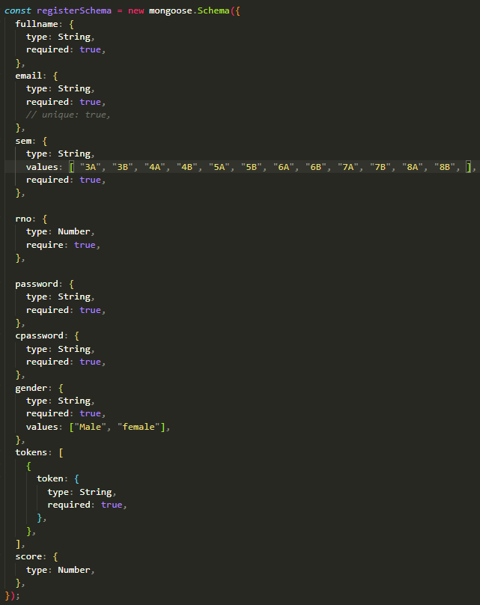

FIG 3.1.1 Register Student Schema

**3.2 SCHEMA FOR TEACHER'S REGISTRATION**

Below image depicts the structure of the MongoDB database object for a particular registration of teacher. Password and Confirm Password will be **Encrypted** using **bcryptJS**.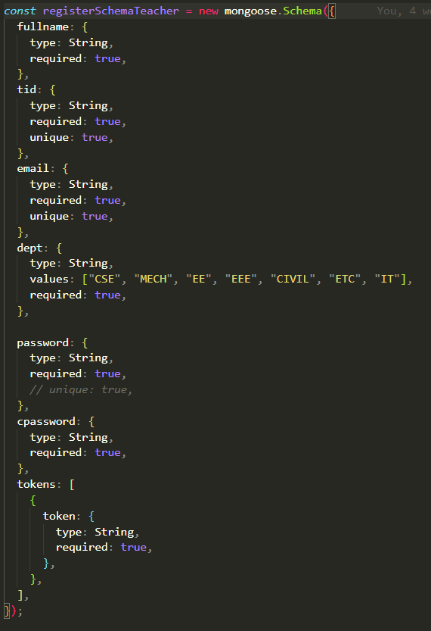

FIG 3.2.1 Register Teacher Schema

**3.3 SCHEMA FOR QUESTION ADDITION**

Below image depicts the structure of the MongoDB database object for a particular Question. Options are stored in an array of strings. Correct Option is a number which is the index value of correct option in the options array.

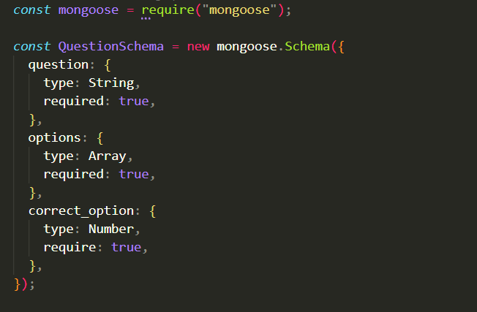

FIG 3.3.1 Add Question Schema

**4. RESULT**

The result of our project is as follow:

* **HOME PAGE**

This is the main home page of Online Assessment Module. From this page teacher or student can go to their respective stream.

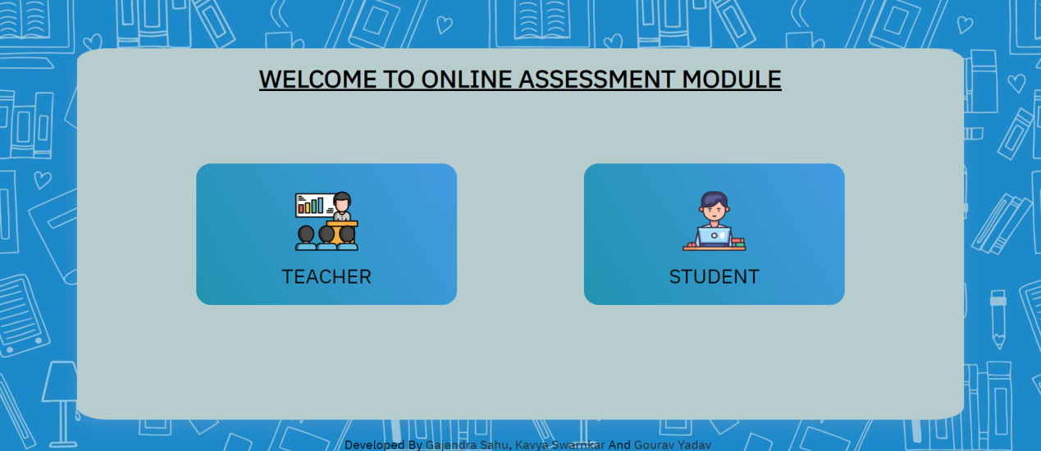

FIG 4.1 Homepage

* **STUDENT'S LOGIN AND REGISTER PAGE BUTTON**

This is the main interface for a student when he/she click on the student portal in the home page. From here a student can register or if he/she is registered he/she can directly login to proceed further.

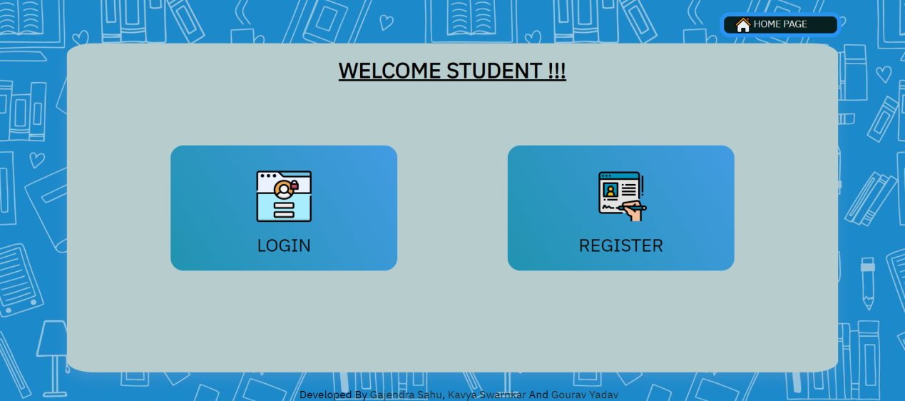

FIG 4.2 Login Or Register Option For Student

* **STUDENT'S REGISTRATION AND LOGIN**

These are the pages which are shown when a student clicks register (FIG 4.3) or login (FIG 4.4). A student can register using his/her credentials and can login by using email and password only.

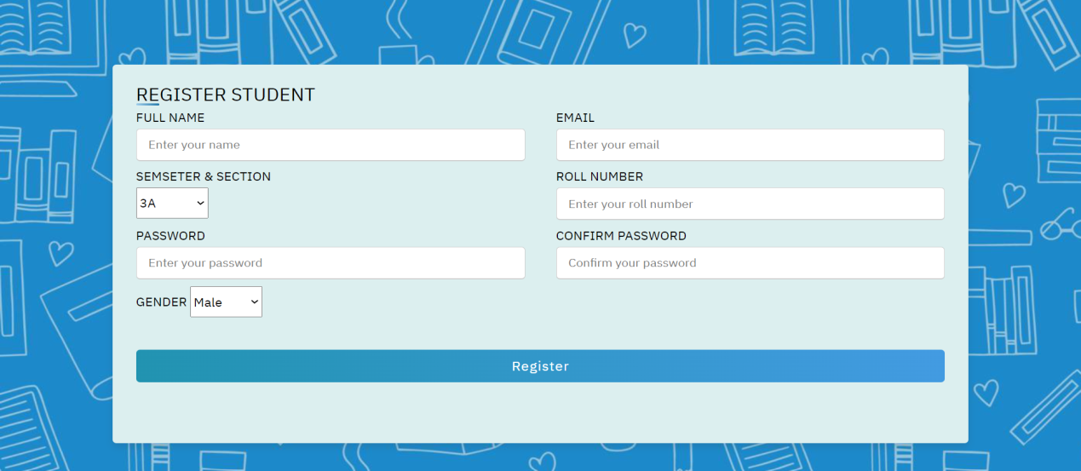

FIG 4.3 Student Registration Page

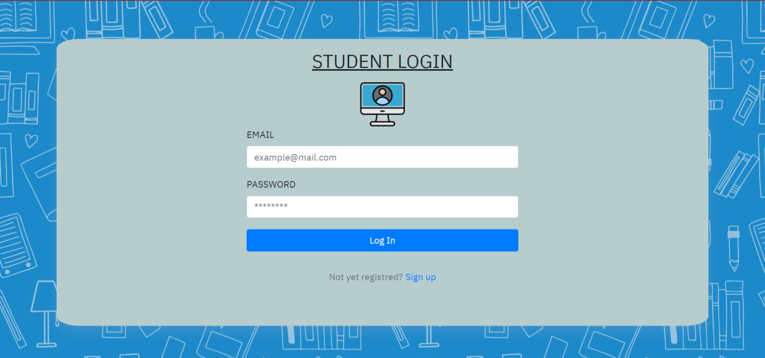

FIG 4.4 Student Login Page

* **STUDENT'S INTERFACE**

This is the page that will be displayed to a logged in student. Student can give test from here on **give test** button or he/she can view his/her result in **view report card** page. Student as well can either logout or jump back to homepage

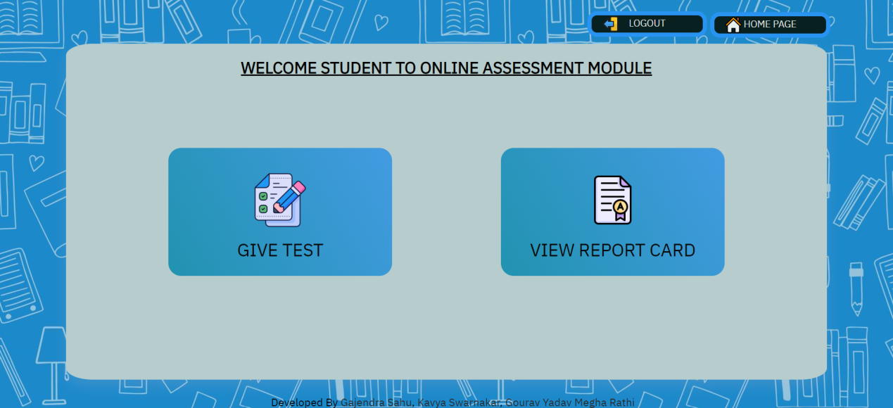

FIG 4.5 Interface For Logged In Student

* **TEST FOR STUDENT**

This page is displayed when a student attempts a test. This has questions with their 4 options and after clicking on their choice of answer of respective student they can submit the test and then they can see their result.

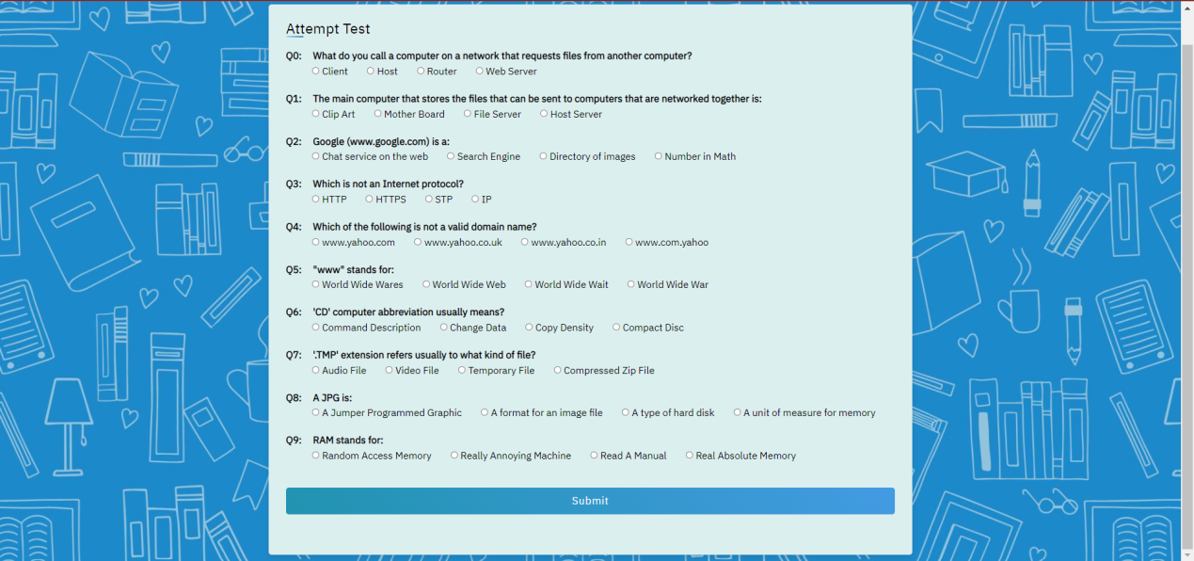

FIG 4.6 Test Interface

* **REPORT OF STUDENT**

This is the View Report Card page for logged in students. Here a respective student can see his/her score in the test. Without logging in student can not see their report and not of others as well.

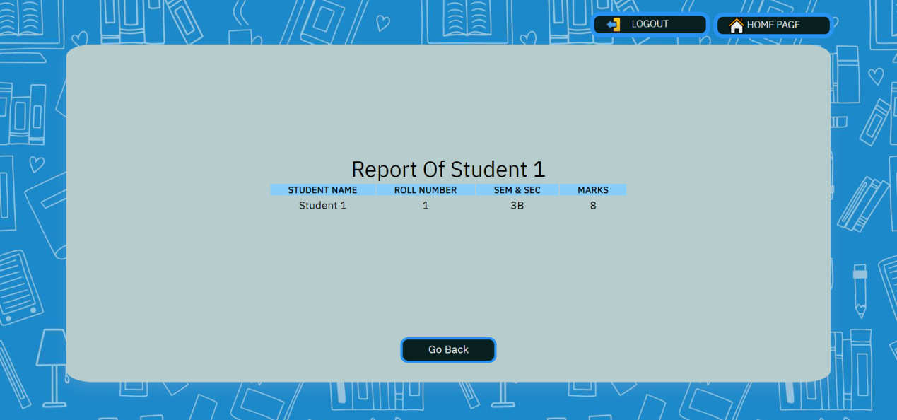

FIG 4.7 View Report Student

* **TEACHER'S LOGIN AND REGISTRATION PAGE BUTTON**

This is the main interface for a teacher when he/she click on the teacher portal in the home page. From here a teacher can register or if he/she is registered he/she can directly login to proceed further.

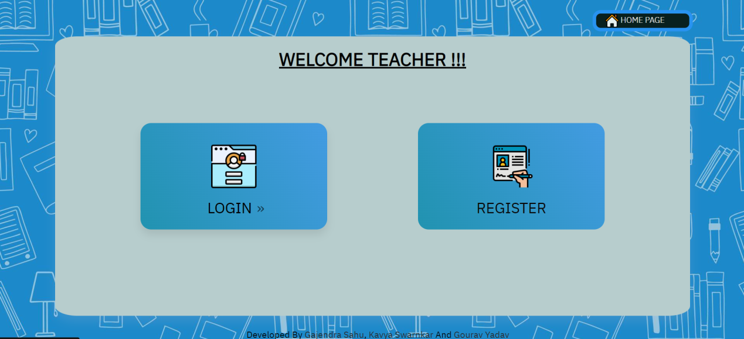

FIG 4.8 Login Or Register Option For Teacher

* **TEACHER'S REGISTRATION AND LOGIN**

These are the pages which are shown when a teacher clicks register (FIG 4.9) or login (FIG 4.10). A teacher can register using his/her credentials and can login by using email and password only.

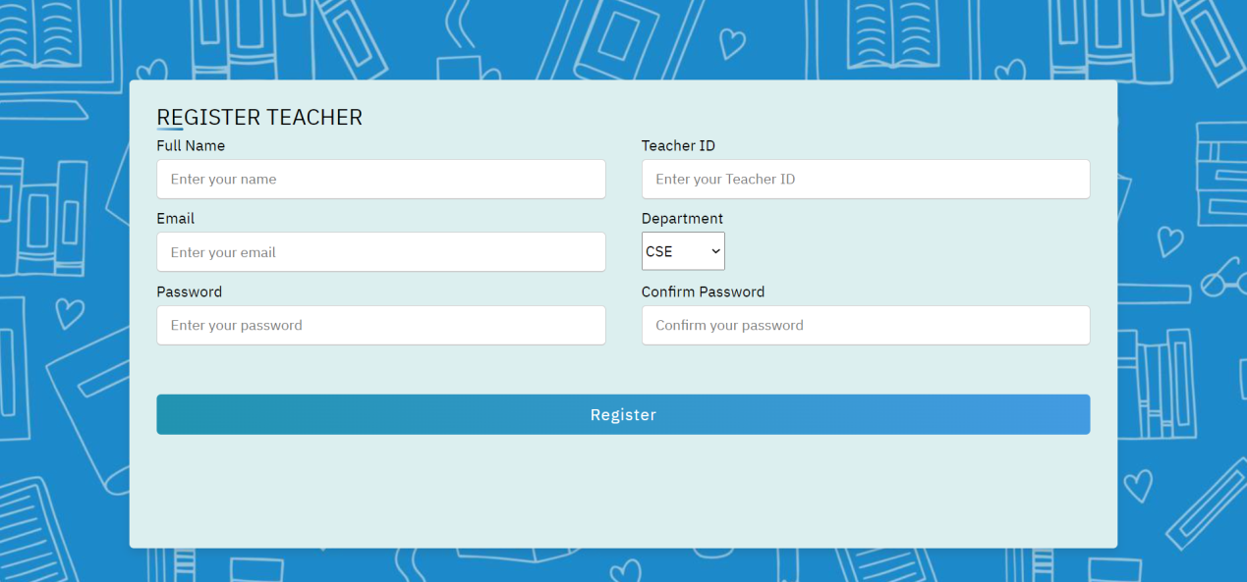

FIG 4.9 Teacher Registration Page

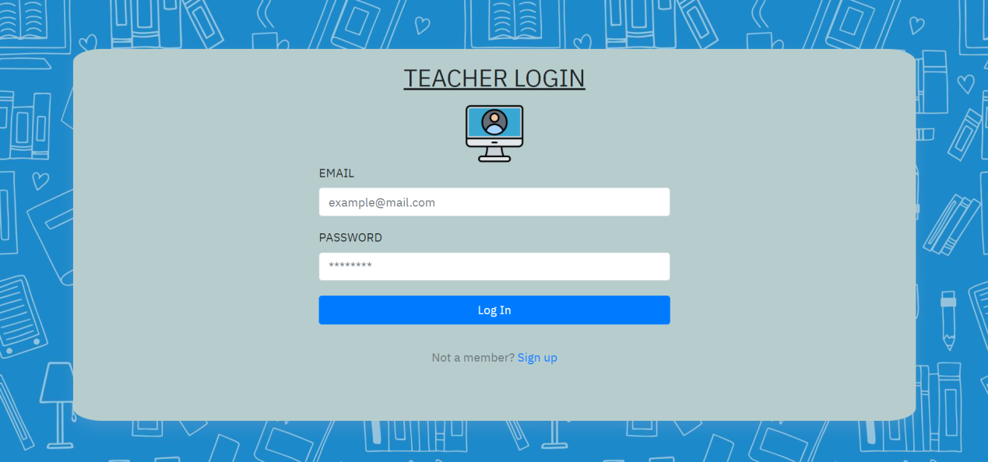

FIG 4.10 Teacher Login Page

* **TEACHER 'S INTERFACE**

This is the page that will be displayed to a logged in teacher. Teacher can add question test from here on **Create Question** button or he/she can view result of all students in **view report** page. Teacher as well can either logout or jump back to homepage

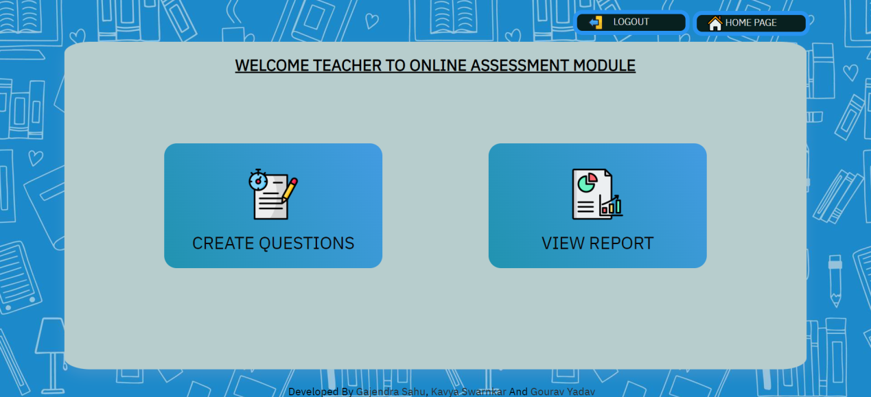

FIG 4.11 Interface For Logged In Teacher

* **ADDITION OF QUESTION BY TEACHER**

This page is displayed when a teacher wants to enter a question for test and can give various required details about question and by clicking add button question can be added and by end button addition of question can be ended and jumped to the main interface of logged in teacher.

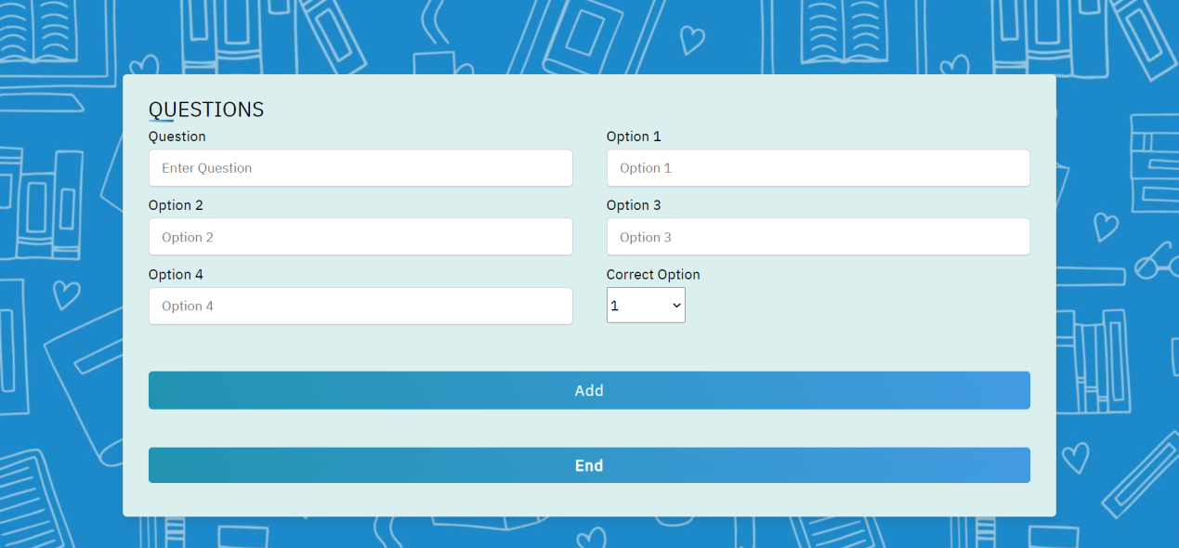

FIG 4.12 Create Question

* **STUDENTS REPORT**

By clicking on view report on the main interface of the teacher he/she can view score of all students. Required data of students will be shown here only on view result page.

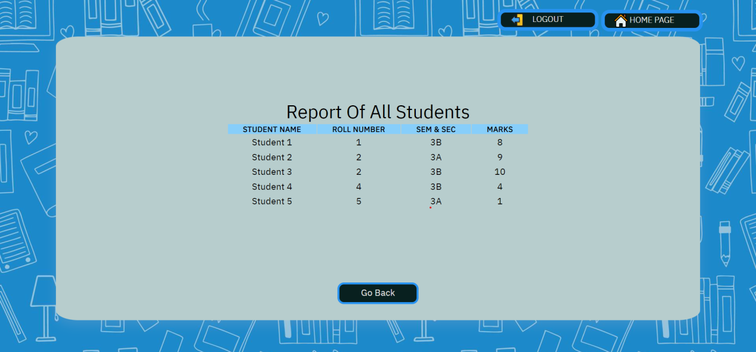

FIG 4.13 Student Report

**5. CONCLUSION**

The impact of technology on the education sector is undoubtedly beneficial. First and foremost, teaching and, in consequence, evaluating students are two actions which should not be limited within the walls of a classroom but they can be both performed anytime, anywhere with the aid of computers and the internet.

It’s not surprising that the industries are gradually moving from using the traditional assessment methods to using more practical ones which are almost always towards technological solutions.

Research has also proven that most students are interested in going through an online assessment rather than a paper-and-pencil one. Moreover, the students are delighted when they get their results and feedback automatically immediately after the test.

**6. FUTURE SCOPE**

With tremendous changes in the educational sector, the use of online assessment has become more popular and widely adopted and our project being of the same category can serve as one of the good alternatives for traditional assessment methods.

**6.1 SCOPE:**

* Conduction of exam effortlessly.
* Promotes social interaction between teachers and students.
* Safe and secured data.
* Reduces administrative burden.
* Based on modern infrastructure

**6.2 FUTURE APPLICATION AND IMPLEMENTATION:**

* Introducing a feature of partial marking for example if in multiple correct question if one answer is marked correct then the student will be getting the marks according to the marking for that particular correct answer instead of complete zero mark.
* Implementing the online assessment feature for our college and then introducing it to other universities.
* We will try to add more features for teachers as well as students.

**7. ADVANTAGES**

* Prompt result after an examination relieves students' anxiety
* Instant feedback supports the formative assessment method
* Conducting an examination anytime, anywhere is beneficial to the students
* Fun and interactive
* Taking exams in a comfortable environment is key
* Beneficial to students who have to prepare for different competitive exams
* Eases out process of online assessment test in institutes.
* Stores requested data of students and question bank of teachers in an order

**8. BIBLIOGRPHY**

[1] “CSS: Cascading Style Sheets” developer.mozilla.org <https://developer.mozilla.org/en-US/docs/Web/CSS>

[2] “Basic concepts of flexbox” developer.mozilla.org <https://developer.mozilla.org/en-US/docs/Web/CSS/CSS_Flexible_Box_Layout/Basic_Concepts_of_Flexbox>

[3] “Using HTTP APIs” devdocs.io <https://devdocs.io/node/http#httpgeturl-options-callback>

[4] “How to connect to mongoDB compass with Node.js” stackoverflow.com <https://stackoverflow.com/questions/51747101/how-to-connect-to-mongodb-compass-with-node-js>

[5]” Password encryption in Node.js using bcryptjs module” geeksforgeeks.org <https://www.geeksforgeeks.org/password-encryption-in-node-js-using-bcryptjs-module/>

[6] “Using JSON Web Tokens (JWTs)” cloud.google.com <https://cloud.google.com/iot/docs/how-tos/credentials/jwts>